

V«utyclc a tu, '\”o ya , S‹'ik

rolliii@, jWyi, @ao‹ law







05-04-2024

…………………

…………………

…………………

Dear Sir/Madam,

Dr. Jeyaseejan Gnanaseelan

BA, PGD in Edu. (TESL),MA Linguistics

MA & MPhil in English, Msc in Human Security

PhD in English SEDA UK-accredited Teacher in Higher Ed i•ya88 ovau.ac.Ik / Mobile: 0717477503

**Subject: Field Observation and Writing Assignment** - **Communication and Soft Skills**

I am writing to request your collaboration on behalf of a first-year student (Name: K. A. Ruwini Tharanga from the Faculty of Applied Science, University of Vavuniya, bearing the Registration No: [Registration Number: 2020/ICT/31). This request is in support of a field observation and subsequent assignment project related to the subject of Communication and Soft Skills.

The student is tasked with engaging with officers and employees across various levels within your organization. The objective is to conduct interviews focusing on the structure, tvpes, and patterns of communication practiced internally and externally with clients and customers. Additionally, the student aims to explore the challenges and obstacles your organization encounters in maintaining efficient and effective communication.

We kindly ask for your permission to allow the student to conduct this assignment within your organization and request your assistance in facilitating their report analysis.

We greatly appreciate your cooperation and support in enhancing the communication skills of our undergraduates.

Sincerely,

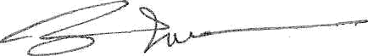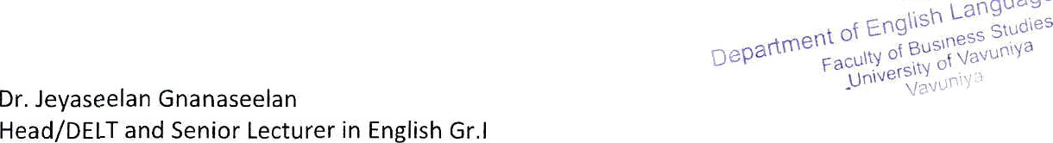

Department of English Language Teaching, Faculty of Business Studies Land Phone: 0242228235/Email: [delt@vau.ac.Ik](mailto:delt@vau.ac.Ik)